**Arsenii Dobrovolskyi**

**MIT-21**

**Lab 2 report**

Task 1 (File encryption and decryption using XOR operation)

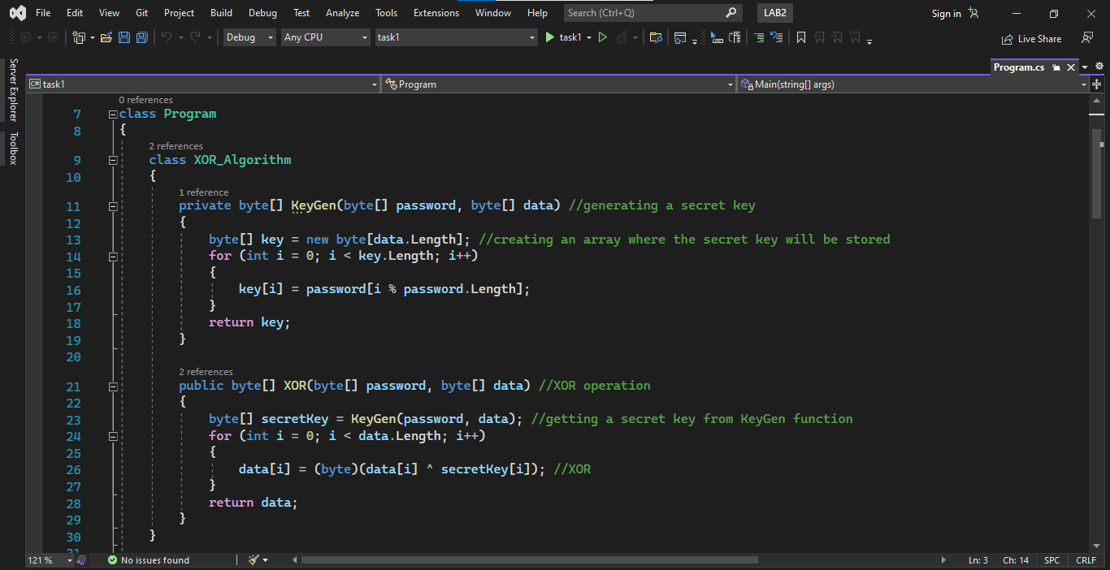

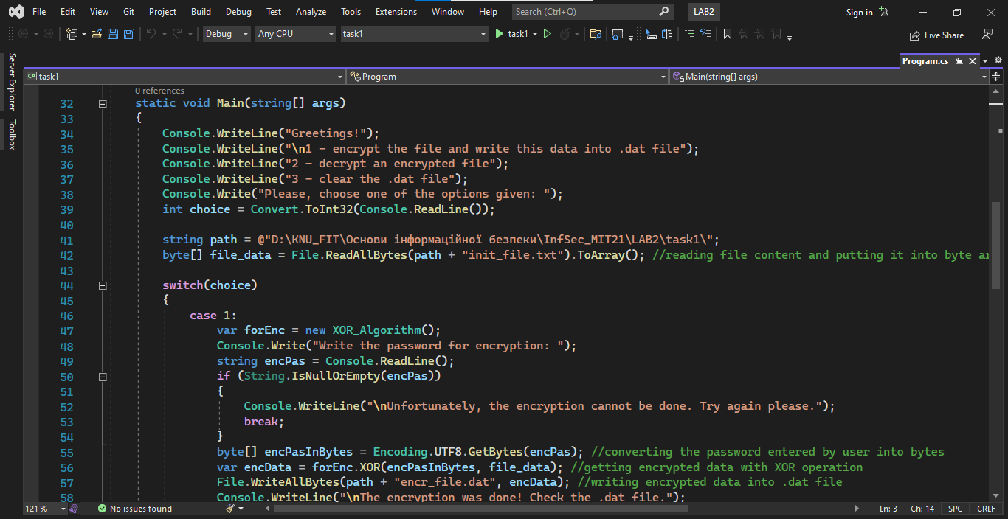

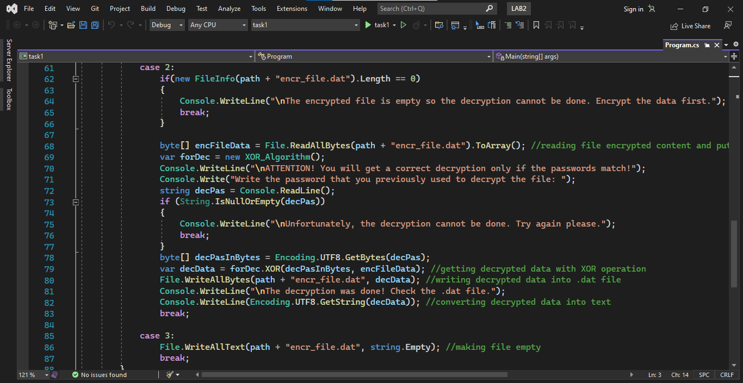

Output:



Task 2 (File decryption using brute force method)

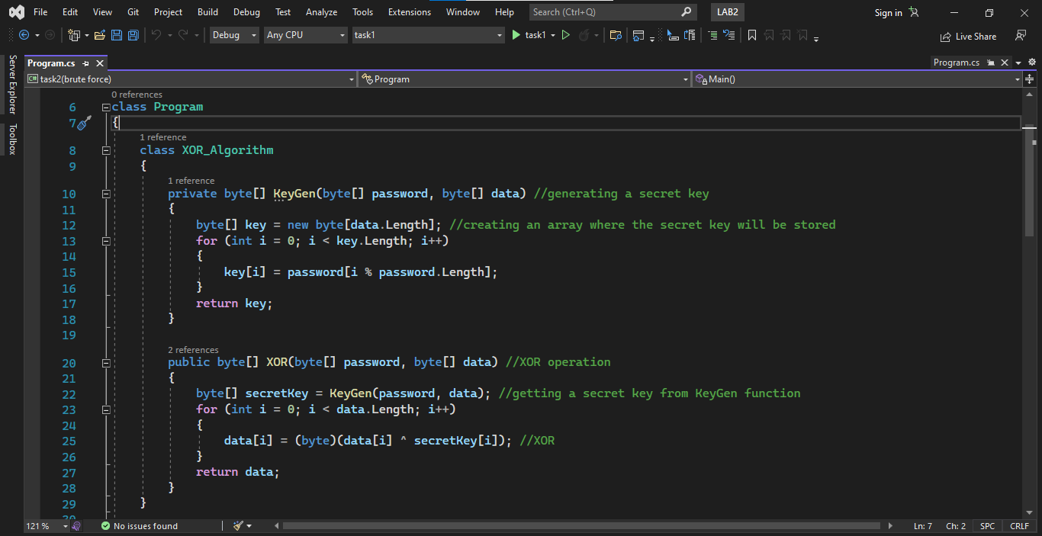

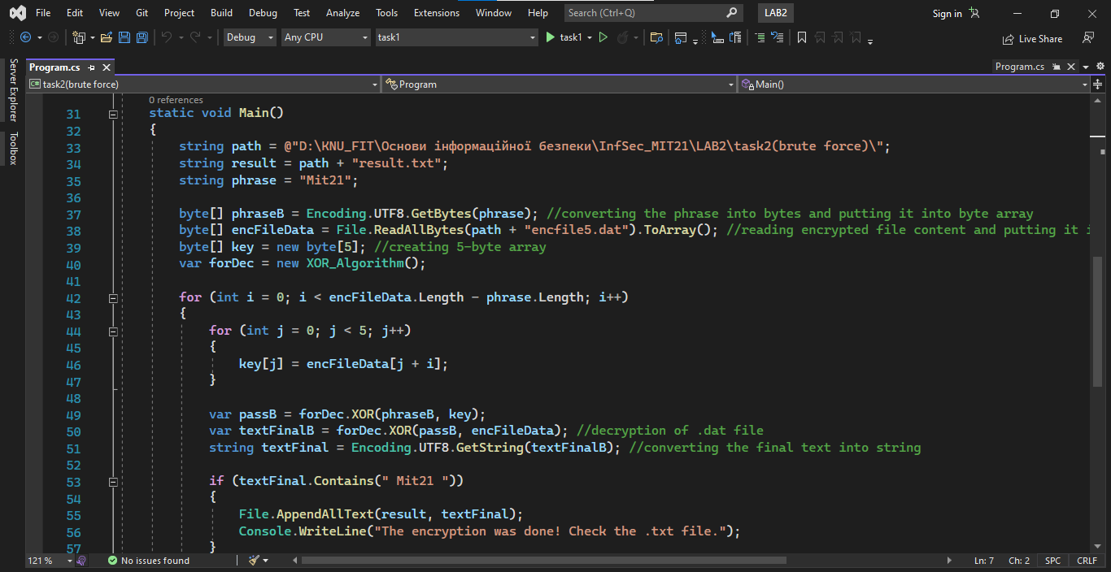

Output:

